Chapter 10, Problem 42.

Using Fig. 10.87, design a problem to help other students to better understand the superposition theorem.
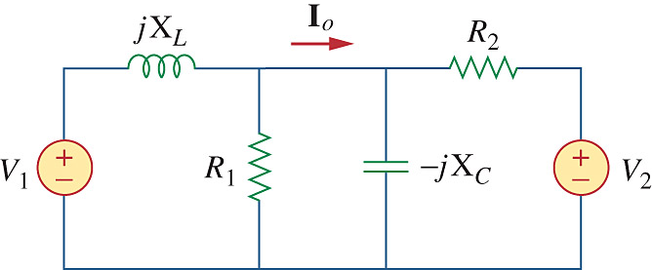

Figure 10.87
For Prob. 10.42.

